GAME DESCRIPTION
Thunder Boost



SYMBOL PAYOUT VALUES

WILD SYMBOL
- [WW] APPEARS ON REELS {2}, {3}, {4}, AND {5} ONLY, AND SUBSTITUTES FOR ALL SYMBOLS EXCEPT [SCATTER] TO HELP FORM WINNING COMBINATIONS.

SCATTER SYMBOL
- [SCATTER] MAY ALSO APPEAR AS A 1X2, 1X3, OR 1X4 LARGE SYMBOL. EACH POSITION IT COVERS COUNTS AS {1} [SCATTER] WHEN TRIGGERING THE FREE GAME FEATURE.

PAYTABLE
[M1] 6 - 400  [M1] 5 - 250  [M1] 4 - 200  [M1] 3 - 150 | [M2] 6 - 250  [M2] 5 - 150  [M2] 4 - 125  [M2] 3 - 100 | [M3] 6 - 200  [M3] 5 - 150  [M3] 4 - 125  [M3] 3 - 50
[M4] 6 - 150  [M4] 5 - 100  [M4] 4 - 75  [M4] 3 - 40 | [M5] 6 - 75  [M5] 5 - 60  [M5] 4 - 50  [M5] 3 - 30 | [M6] 6 - 75  [M6] 5 - 60  [M6] 4 - 50  [M6] 3 - 30
[A] 6 - 50  [A] 5 - 40  [A] 4 - 30  [A] 3 - 20 | [K] 6 - 50  [K] 5 - 40  [K] 4 - 30  [K] 3 - 20 | [Q] 6 - 20  [Q] 5 - 15  [Q] 4 - 10  [Q] 3 - 5
[J] 6 - 20  [J] 5 - 15  [J] 4 - 10  [J] 3 - 5 | [10] 6 - 20  [10] 5 - 15  [10] 4 - 10  [10] 3 - 5

CASCADING FEATURE
- AFTER EACH WIN EVALUATION, WINNING SYMBOLS ARE REMOVED, THE REMAINING SYMBOLS CASCADE DOWN, AND NEW SYMBOLS FILL THE EMPTY POSITIONS.
- AFTER THE REELS ARE REFILLED, NEW WINNING COMBINATIONS ARE EVALUATED AGAIN. THIS PROCESS CONTINUES UNTIL NO NEW WINNING COMBINATIONS ARE FORMED.

MULTIPLIER FEATURE
- IF MULTIPLE [M1] SYMBOLS APPEAR IN THE SAME ROUND, THEIR MULTIPLIER VALUES ARE ADDED TOGETHER.
- THE MULTIPLIER AWARDED BY [M1] ON THE MAIN REELS IS DETERMINED BY THE SYMBOL SIZE.
- EACH [M1] ON THE EXTRA REELS AWARDS A FIXED X{2} MULTIPLIER.
- ALL WINS IN THE CURRENT ROUND ARE MULTIPLIED BY THE TOTAL ACCUMULATED MULTIPLIER FOR THAT ROUND.
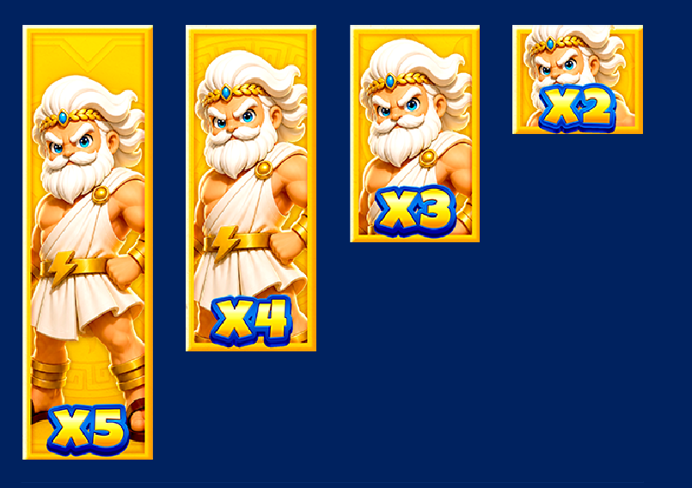

GOLDEN FRAMED FEATURE
- GENERAL SYMBOLS ON REELS {2}, {3}, {4}, AND {5} MAY APPEAR WITH A GOLD FRAME.
- A GOLD FRAMED SYMBOL ONLY CHANGES INTO [WW] ON THE SAME POSITION AFTER IT ACTUALLY PARTICIPATES IN A WIN AND IS REMOVED.
- THE TRANSFORMED [WW] CAN PARTICIPATE IN THE NEXT WIN EVALUATION AFTER THE CASCADE.
- THE TRANSFORMED [WW] REMAINS FOR {1} CASCADE ONLY, AFTER WHICH THE REELS UPDATE NORMALLY.

FREE GAME FEATURE
- {4} OR MORE [SCATTER] APPEARING ANYWHERE ON THE REELS (INCLUDING THE EXTRA REELS) WILL TRIGGER THE FREE GAME FEATURE.
- {4} [SCATTER] AWARD {10} FREE SPINS. EACH ADDITIONAL [SCATTER] AWARDS {2} MORE FREE SPINS.
- A MAXIMUM OF {50} FREE SPINS MAY BE PLAYED DURING EACH FREE GAME FEATURE.
- THE ACCUMULATED MULTIPLIER STARTS AT X{2} WHEN THE FREE GAME FEATURE BEGINS.
- DURING FREE GAME, THE ACCUMULATED MULTIPLIER IS NOT RESET BETWEEN SPINS AND IS CARRIED OVER UNTIL THE ENTIRE FEATURE ENDS.
- DURING FREE GAME, {4} OR MORE [SCATTER] WILL RETRIGGER ADDITIONAL FREE SPINS. THE SAME FREE SPIN AWARD RULE APPLIES, UP TO A MAXIMUM OF {50} FREE SPINS IN TOTAL.

OP JACKPOT
- OP JACKPOT FEATURE IS TRIGGERED RANDOMLY BY {1} OR MORE [SCATTER] ON THE REELS.
- DURING OP JACKPOT FEATURE, THERE ARE {12} [COIN] WHICH CONSIST OF [GRAND], [MAJOR], [MINOR] AND [MINI].
- SELECT A [COIN] TO REVEAL [GRAND], [MAJOR], [MINOR], OR [MINI].
- IF PLAYER GETS {3} SAME JACKPOT SYMBOLS WILL WIN THE JACKPOT AND CALCULATE TOTAL WINNINGS.
- [GRAND] IS LINKED PROGRESSIVE JACKPOT.
- [MAJOR] IS LINKED PROGRESSIVE JACKPOT.
- [MINOR] WILL CHANGE IF THE PLAYER SELECTS DIFFERENT BET OPTION.
- [MINI] WILL CHANGE IF THE PLAYER SELECTS DIFFERENT BET OPTION.
- THE HIGHER BET, THE HIGHER CHANCES TO TRIGGER OP JACKPOT FEATURE.

WAY GAME
- THIS GAME USES A WAY GAME MECHANIC THAT PAYS FOR MATCHING SYMBOLS ON CONSECUTIVE ADJACENT REELS FROM LEFT TO RIGHT.
- THE MAIN REELS CONSIST OF {6} VARIABLE-HEIGHT REELS, WITH {1} EXTRA REEL POSITION ABOVE REELS {2} TO {5}.
- THE NUMBER OF WAYS IN THIS GAME RANGES FROM {2,025} WAYS TO {32,400} WAYS.
- A LARGE SYMBOL COUNTS AS {1} SYMBOL FOR WAY CALCULATION, REGARDLESS OF HOW MANY POSITIONS IT COVERS.
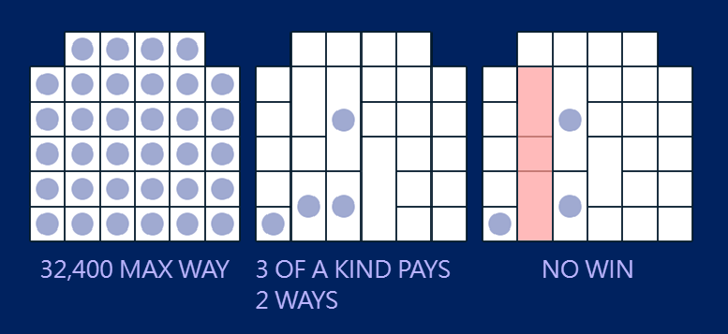

GAME RULES
- SELECT BET OPTION YOU WISH TO PLAY.
- ALL WINS ARE MULTIPLIED BY BET OPTION EXCEPT PROGRESSIVES BONUSES.
- MALFUNCTION VOIDS ALL PAYS AND PLAYS.
- IF THE PLAYER LOSES CONNECTION DURING THE FREE GAME FEATURE, THE SYSTEM WILL COMPLETE THE RESULT AUTOMATICALLY AND ADD ANY WINNINGS TO THE BALANCE.

